Practical Gaming 2024

Name of Student
Sofiia Fedchuk

T Number
T00264753

Name of Project
Motorcycle Racing Simulator

Gameplay
Game Controls for Player:
Keys A/D to strife Left/Right
Left Shift key to increase speed
CTRL key to slow down
Mouse Pointer to look Left/Right
Dialogue with options (Left option, Straight option and Right option) will appear near road intersections
Gameplay:
Motorcycle under Player drive continuously on the road. Player can use A/D keys to avoid obstacles on the road that will deal damage to Player or to pick up items that will heal the player.
The road, buildings and other object in the surrounding environment are generated randomly.
When Player is approaching intersection the dialogue with three or two will be prompted and player should choose one of these options. Then animation of turning motorcycle will be performed.
When Player is approaching corners the animation of turning motorcycle will be performed.

Coding

- Frame Rate Independence
To ensure that movement, and physics behave consistently across different devices I used FixedUpdate(), Time.fixedDeltaTime and AddForce():
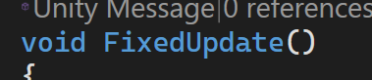
- Interfaces
Implemented an IHealth interface to define health-related behaviour across player and pick-up items:
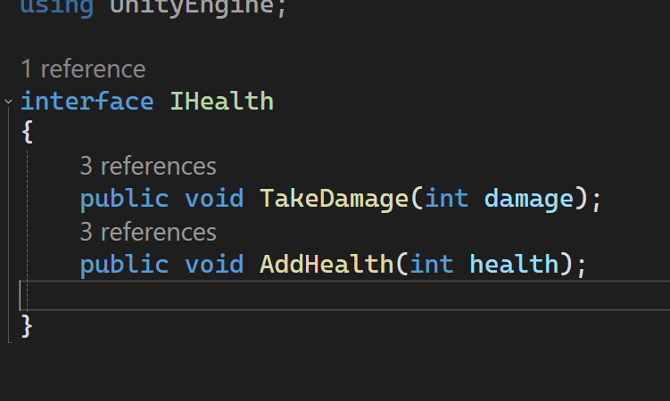
- Inheritance
I used inheritance to implement my pick-up item system with base class that defined shared behaviour and derived classes that represented “good” and “bad” items:
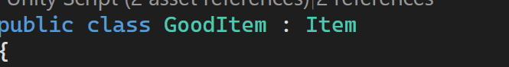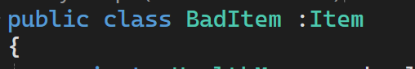
- Case pattern

I used switch statements to manage player and dialogue states allowing different behaviours to be executed depending on current state:
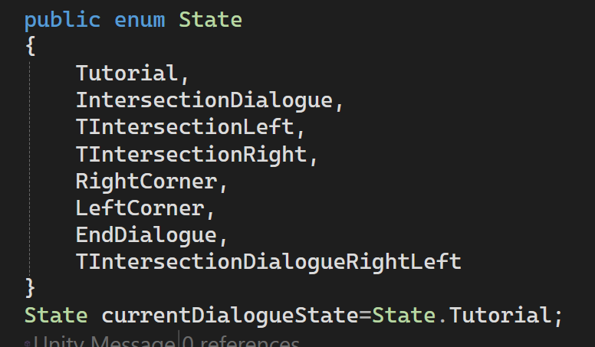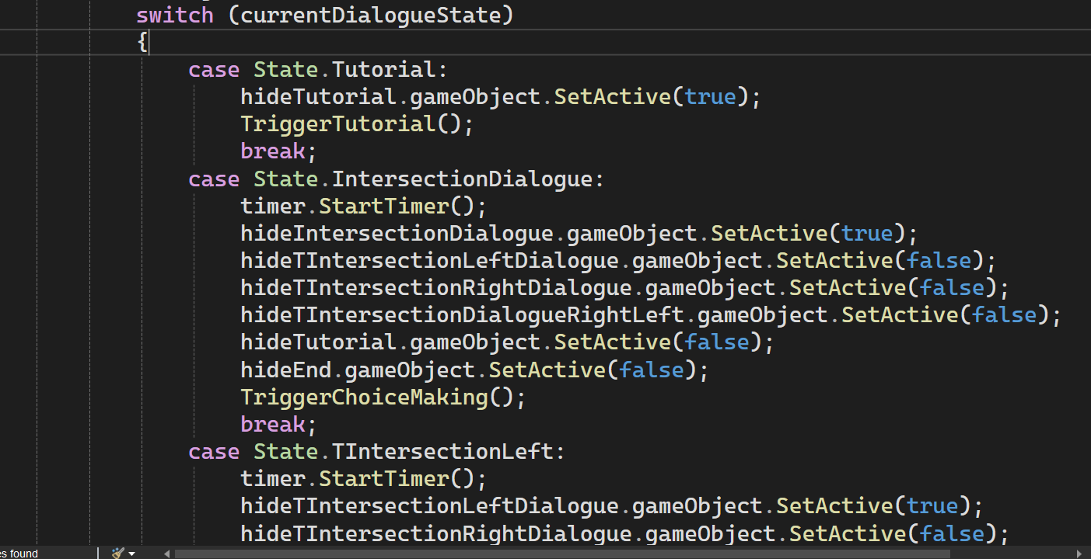

- Observer Pattern
I implemented pick up items system by using observer pattern allowing objects to react to events:

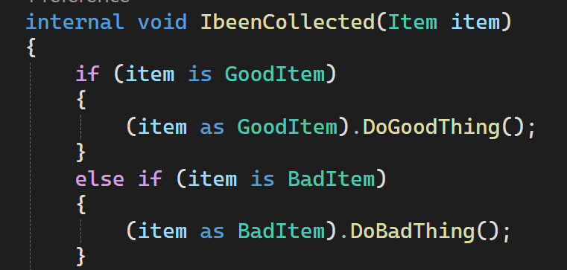
- Polymorphism
To show polymorphism, I created health and pick-up items system by using inheritance and interfaces. I used this because I needed different implementations that can be accessed and executed through common interface:


- Communication between scripts/game objects

Communication between scripts and game objects are done through GetComponent<>() references or referencing to custom class/scriptable object:
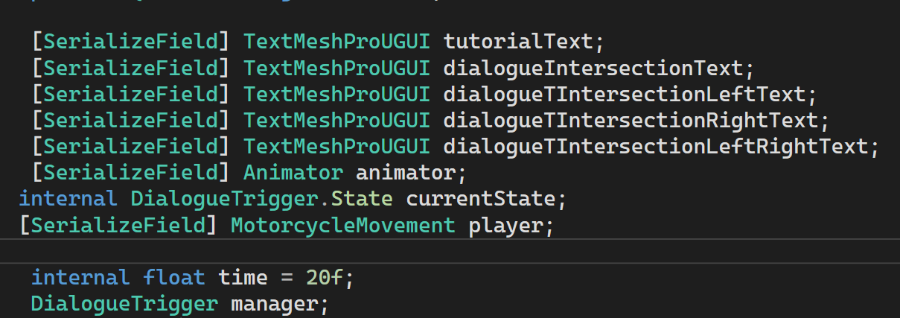

- Instantiation and Prefabs

As a part of the procedural generation, I used prefabs and instantiated them dynamically through code:
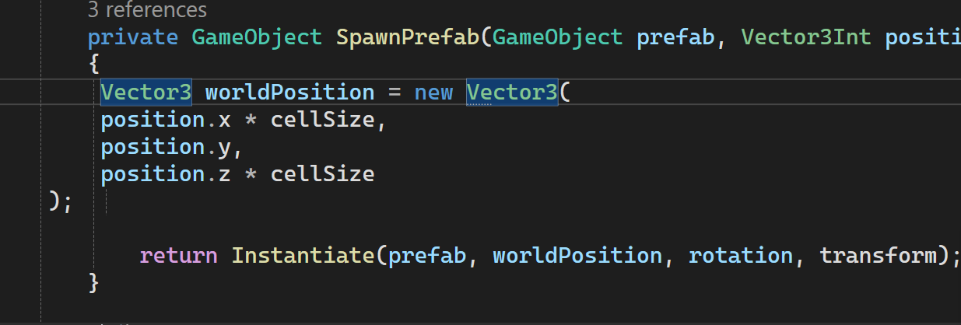

- Magic Numbers
I avoided using magic numbers in my code and replaced them with named constraints to improve code readability and maintability:
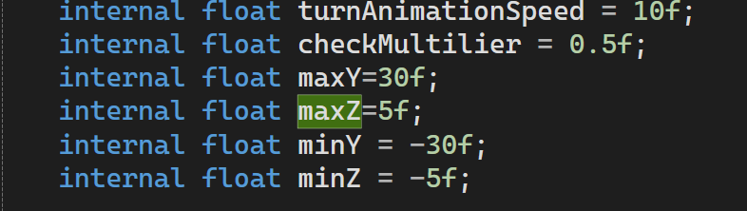
- Model Animation
I created the model animation of wheels and handle of motorcycle through script:
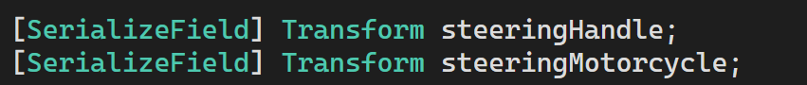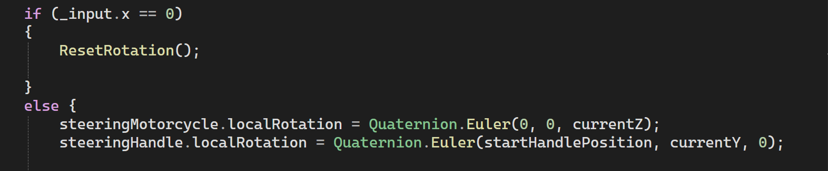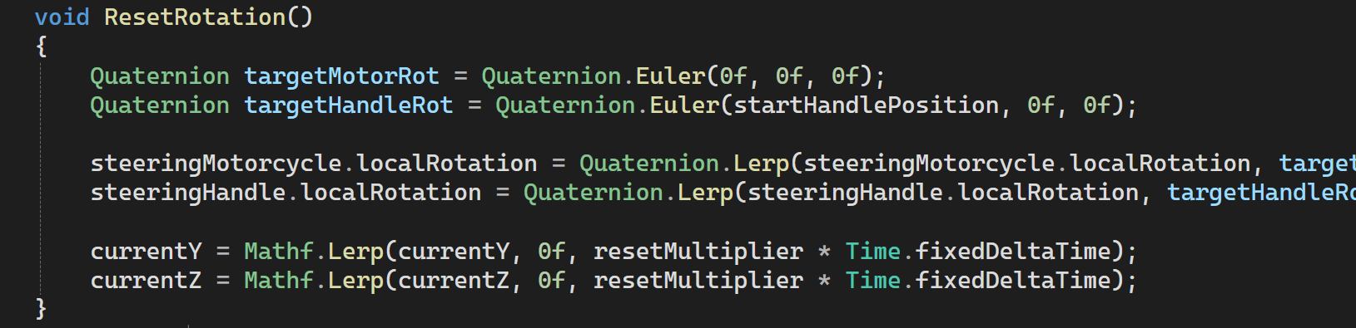

- Self made models and or animations
Both animations of dialogue appearing on screen and motorcycle’s handle/wheels turning were self-made through code and Unity animator.
- Interactions between objects/scripts
Some objects(like player) can interact with other objects during collisions. I used tagging feature in Unity for that. There are also state changes based on trigger events or button click events:
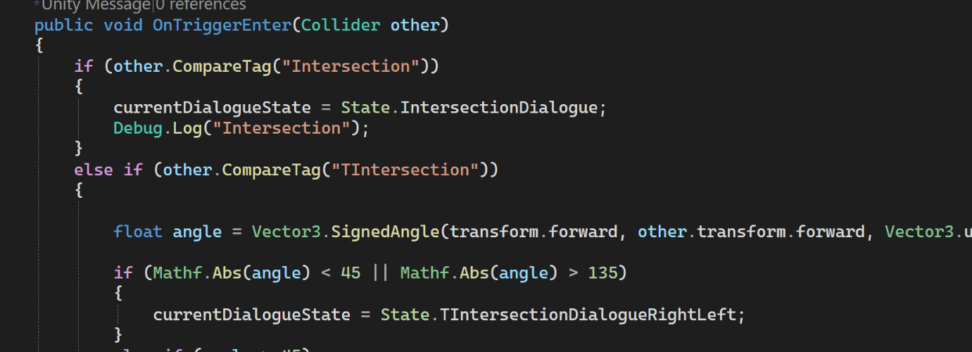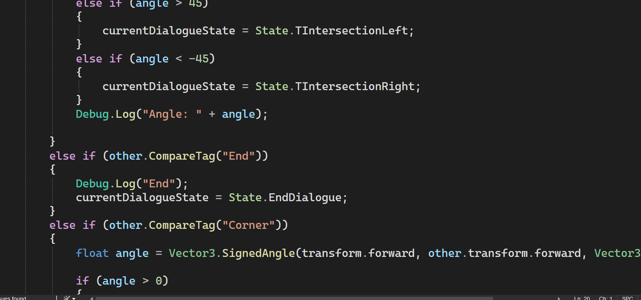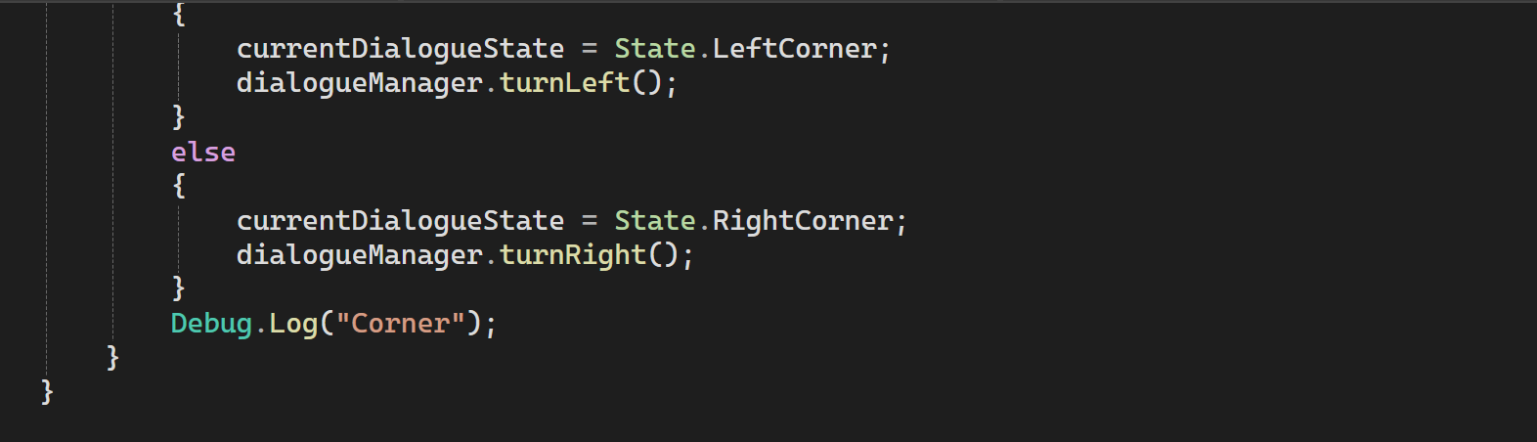

- Propper code placement
All scripts will be structured and placed by me in specific folders:
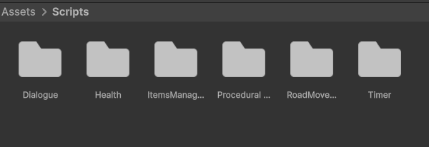

- Code repetition
Code was separated into different classes(scripts) to ensure that code repetition doesn’t exist:
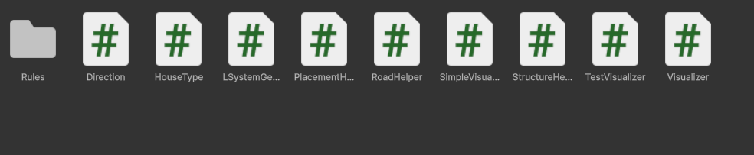
- Credits:

- Modular Roads Pack on Sketchfab: "Simple Modular Roads System" (https://skfb.ly/6YFPZ) by Gazi Akviran is licensed under Creative Commons Attribution (http://creativecommons.org/licenses/by/4.0/).
- Toolbox on Sketchfab: "Toolbox" (https://skfb.ly/o8zrQ) by Dumokan Art is licensed under Creative Commons Attribution (http://creativecommons.org/licenses/by/4.0/).
- Road cone on Sketchfab: "Road Cone" (https://skfb.ly/psBPp) by Emil Gilmutdinov is licensed under Creative Commons Attribution (http://creativecommons.org/licenses/by/4.0/).
- Buildings pack on Sketchfab: "Brownstone Building Set - Low poly model" (https://skfb.ly/puIWX) by Daniel Zhabotinsky is licensed under Creative Commons Attribution (http://creativecommons.org/licenses/by/4.0/).
- Motorcycle 3D model on Unity Assets store: https://assetstore.unity.com/packages/3d/vehicles/land/honda-super-cub-c125-270101
- Sitting player 3D model on Mixamo: https://www.mixamo.com/
- Tutorial on Procedural Town Generation from Sunny Valley Studio: https://www.youtube.com/watch?v=umedtEzrpvU&list=PLcRSafycjWFcbaI8Dzab9sTy5cAQzLHoy

